Other way to run shell script is :-
- <shell-name> <script-name.shell-name>
Like $ /bin/bash shell.sh
Like $ sh shell.sh

- (Preferred) Give permission like chmod u+x shell.sh :- for current user only
And run this :- ./shell.sh

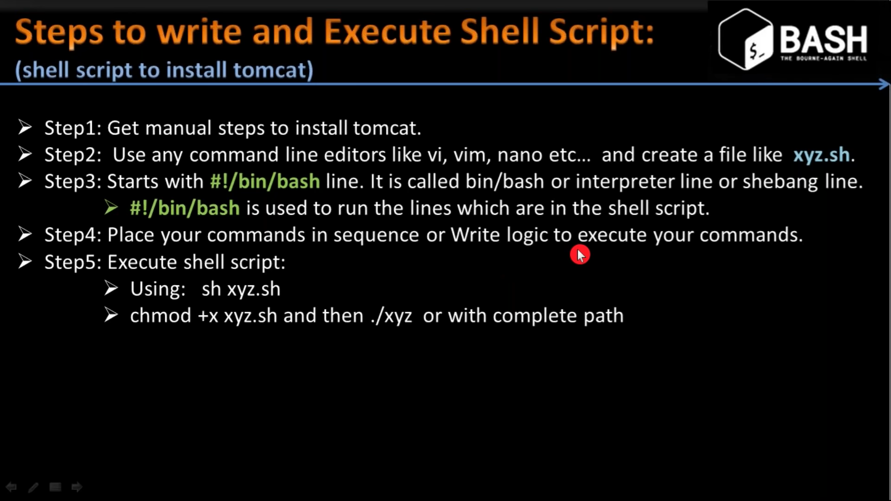

Now here is problem we just use command in sequence , which is not a good idea because :-
- Suppose a perticular command is not present we need to make inform user about
Like “wget” is not present in system and we use it in script

- Suppose we give a hard coded URL and and if we want change so a user input should be there

So many things like that …..

